Safavi_M2 Text_5 November, 2020

**Title:**

**Challenging the Assumption of Inadequate Personal Care Practices**

**as the Main Cause of COVID-19 Pandemic in the Islamic Republic of Iran**

**Abstract**

Russians and Iranians have been among those nations which have been severely affected by COVID-19 both in terms of infections and deaths. While they share many attributes, which would have provided immunity to infectious diseases, the Iranians have been blamed for the spread of the coronavirus because of alleged careless use of personal hygiene products. This essay challenges this notion and investigates the recent history of Iranian engagement with high-quality personal hygiene items which would serve to prevent the spread of the coronavirus. Data have been collected on the import/consumption of global brands of soap, toothpaste, and shampoo during the past 17 years and analyzed to determine the commitment of the Iranian population to their health issues. It was noted that in spite of a large price gap between the domestic and global brands, a section of the Iranian population has continuously and persistently increased their purchase of global brands due to perceived higher quality out of concern about their personal health.

A series of business models are used to process available data while focusing on probable caveats of each model and exhibiting the Iranian genuine adherence to the import and consumption of high-quality brands. Paired means analysis suggests that the rate of import of soap, toothpaste and shampoo were significantly higher than the rate of population growth with p<0.05. The Cohen’s d-test offered the standard deviation of 0.419 for soap, 0.567 for toothpaste, and 0.751 for shampoo. Likewise, the imported volume of Toothpaste and Shampoo (CIF values in local currency) were significantly larger than the magnitude of price increase for these items (toothpaste: p=0.007, shampoo: p=0.009, respectively) confirming the notion that the Iranian commitment to high-quality personal hygiene products was not diminished due to the rise in prices. Cohen’s d-test produced 0.614 for toothpaste and 0.829 for Shampoo, suggesting a large difference between the flow of imported volume and the price of toothpaste and shampoo over the 17-year period. Future results should incorporate similar data from Russian consumers to generate bi-national comparative information on this critical issue.

**The Issue**

There are many commonalities between the two nations of Russia and Iran. Both nations live on a mass piece of land; Russia on the largest land area in Europe, 17,098,246 Km2; and Iran on the second largest area in the middle east, 1,648,195 Km2 (World Bank, 2020). Both nations have the largest population in their geographic region, Russia 145,948,710, and Iran 84,289,869 respectively (World Population review, 2020). The two nations enjoy massive volume of oil and gas, Russia ranking 1st in national gas reserves (Anadolu Post, 2020), and Iran ranking 2nd in national gas reserves (EIA 2020). Each of the two nations possess a large variety of minerals, Russia having $75 trillion and ranking 5th in the world (Investopedia, 2020), and Iran ranking among the top 15 major mineral countries, having 68 types of minerals consisting of 37 billion tons of proven reserves, and more than 57 billion tons of potential reserves valued at $770 billion (Wikipedia, 2014). Both nations have produced incredible literary personalities. The two are among the top 8 contenders of World Volleyball Cup; Russia ranking 5th and Iran ranking 8th (TheSports, 2019). Sadly, both nations share a bitter experience of heavy sufferings from the Covid-19; (Russia , with 1,312,310 infections and 22,722 deaths; Iran with 500,075 infections and 28,544 deaths (WHO, 2020a).

From the early stages of the coronavirus Iran has been one of the epicenters of the pandemic, ranked 1st in the Middle East region (WHO, 2020b). Candid explanation for this global suffering was given as the lack of sanitary conduct, specifically the inadequate personal hygiene care, and the political motivation of the government to minimize the psychological impact of the pandemic (New Yorker, 2020). They were told that if they washed their hands frequently and socially distanced, they would not be affected (Cambridge, 2020).

The reality paints to a different picture, however. The Iranians have long been a firm adherent to their personal hygiene care. Indeed, they were so conscious about their health that they paid higher prices for the imported brands of personal hygiene items than for the lower-priced domestic products due to their perceived superior quality. This financial sacrifice happened even at a time when the price difference was high.

**The Question**

Is the spread of Covid-19 pandemic in the Islamic Republic of Iran due to the nation’s lack of concern about their personal hygiene care, or were other external factors the main players?

**The Criterion**

The main criterion for determining Iranian adherence to their personal health as a preventive mechanism to COVID-19 is their genuine willingness to use high-quality personal hygiene products even if high prices requires financial sacrifice.

**Benchmark**

Since international brands of personal hygiene products enjoy higher perceived quality, the larger rate of increase in their import/consumption over the rate of population growth can be a proxy for the continuous devotion of the Iranians to their healthcare efforts. It should be noted that the effective results of their use are also a function of how the product is applied to the body. If the application procedure is wrong, then the high-quality product would not be effective in immunizing the consumer. The wrongful application of quality hygiene products is usually a function of the users’ limited information, and not their intentional decision. They are cases about the ineffective use of the quality soap, toothpaste, and shampoo in less developed areas of Iran.

In a study of head lice infestation among the girl students of Bashagard County in southeastern Iran - - a low-income community - - Soleimani-Ahmadi (2017) and his associates at Hormozgan University of Medical Sciences in Bandar Abbas, Iran, noted an infestation rate of 67.3%. There was also a significant association between head lice infestation and school grade, family size, parents’ literacy, bathing facilities, frequency of hair washing, and use of shared articles (*p* < 0.05). The effectiveness of 1% permethrin shampoo for head lice treatment was 29.2%, 68.9%, and 90.3% after the first, second, and third weeks, respectively. Girls with uneducated mothers and fathers depicted a rate of 82.4% and 81% respectively, while girls whose parents had a high school diploma and higher exhibited the rate of 6.7% and 14.3% infestation, respectively. Girls who shared their combs and scarves with others exhibited a 71.7% infestation rate compared with girl students who did not use shared articles (60%) (p = 0.043). It is evident that the way consumers use shampoo in Iran is also a factor contributing to their health aside from the quality of the brand used.

In similar studies made by Newson et al (2013) in 12 developing countries, it was revealed that the way consumers used soap for hand washing is a very effective tool for developing immunity against infectious diseases. It appears that emotional appeal would be more effective than traditional knowledge-based awareness-raising campaigns in persuading people to make better use of personal hygiene products.

Dr. Lacruz of New York University College of Dentistry (Iran Daily, 2020) noted that while low levels of fluoride is beneficial in preventing fluorosis and the discoloring of tooth enamel, especially for children under 9 years of age, a high level of its use would contribute to these ailments . Partly within this consideration, Iranian health specialists associating with the international public health organizations, have been active in providing guidelines for more effective measures of washing hands even before the emergence of COVID-19 (Allegranz, 2017).

**The Research Objective:** To investigate the commitment of the Iranian people to their health as a precaution against the infections including the risk of exposure to coronavirus.

In order to arrive at a reliable answer, we proceed with our analysis in the following steps:

1. Selection of the criteria for health-conscience behavior. It is generally believed that the use of high-quality personal hygiene products is an indicator of health driven behavior. We chose the global (imported) brands of three widely used items in this product category. They are 1. Soap, 2. Toothpaste, and 3. Shampoo. The rationale for selecting these products rests on the fact that washing hands with quality soap would help preventing virus spread; the toothpaste cleans the mouth and teeth, making them immune to many diseases. Shampoo prevents the penetration of germs from the head into the body. Our observations are focused on the use of the imported brands since many Iranian consumers perceive international brands to have superior quality over the local brands. This widely-held opinion is based on the reality that international manufacturers of hygiene products enjoy higher quality resources than the Iranian producers, thereby contributing to a higher standard of healthcare. Their perception is based on the fact that the international brands enjoy better ingredients and advanced technology. If the country of origin is a perceived indicator of the quality of imported goods, the fact that the entire volume of soap brought to Iranian customs during 2018 was from 3 countries of France, Germany, and UAE, while 54.6% of the entire volume was imported from France (Baghishov, 2018) speaks to the quality-conscious Iranian consumers. In 2016, a large volume of personal healthcare products produced by Unilever, a British-Dutch multinational corporation, was shipped to Iran from its manufacturing plant in Russia (RCISBFD, 2016).
2. Access of the Iranian consumers to international brands is largely provided through importation of these products by private merchants. Imported items generally go through the Iranian custom organization where they are inspected and charged tariffs. Custom authorities record every imported item by three scales: 1. The product weight in kilogram, 2. The Cost, Insurance, and Freight (CIF) value of the item in the local currency, which is the Iranian Rial and 3. The CIF value of the item in US dollars. The combination of these three personal care products, assessed by their different scales, help in assessing the level of Iranian consumers’ commitment to the use of quality personal hygiene products as precautions against environmental diseases.
3. While custom authorities have recorded data for the past 30 years, we have noted reliable data for these three products since 2001. However, commanding external factors such as a huge influx of petrodollar by the early 21st century contributed to a very high level of import for these two products in the year 2003. For this reason, we have not included data for the years 2001 and 2002 in our longitudinal analysis to prevent the disturbing influence of outliers. By the same token, the imposition of maximum pressure sanctions on Iranian trade by the US government in 2017 caused drastic decline in the import of these three personal hygiene products in 2018. Since the resultant lower availability of imported three products did not reflect the Iranian consumer’s preference for high-quality products, we had to treat imported volumes for the year 2018 as outliers and remove them from our analysis. In a study of the consumer demand for Fast Moving Consumer Goods (FMCG), Bhardwaj (2016) noted that during the economic downturn consumer demands, even for basic and essential products such as soap and toothpaste, decreased in India and would take a relatively long time to recover as consumers have changed their behavior to low-cost brands. Two years later, Malviya (2018) noted that although total demand for consumer goods fell in India, consumer choice for branded products increased. As a result, our dataset encompasses a serial data for the years 2003-2017. We are assured that our data is factual, reliable, and authentic.
4. Meanwhile, comparative data for local production for soap, toothpaste, and shampoo have been compiled by the Ministry of Industry, Mine, and Trade. Their reliable date begins from the year 2010. This inequality in the span of time (15 years for imported vs. 8 years for local production) would make comparative analysis a difficult task. Accordingly, in order to benefit from a larger range of data over a relatively large span of time, (2003-2017), we have concentrated only on data for import, and compared them to the rate of population growth during the span of the recent 15 years.
5. Politics have intervened in consumer preferences for global brands in Iran and other countries in the region. National governments encourage, and in many occasions force, its citizens to buy local brands in order to stimulate their feeble economies. In India where global brands of toothpaste, soap, shampoo, skin creams, and laundry detergent have earned around 50-65% of market share, the prime minister has urged citizens to be "vocal about local brands" and have a vision of a self-reliant India (Mukherjee, 2020).
6. **Theoretical Foundation:** While dealing with a limited database for assessing the level of Iranian commitment to quality international brands, certain adjustments must be made to the conventional theories to be able to rely on data from import and population growth. Every pattern of relationship between the quantity and financial values of imported personal hygiene products, and the magnitude of population being present at each unit of time (1 year) could be subject to the omission of other relevant variables in the analysis. The omission could have contributed to an entire different understanding of the situation. We refer to these omissions as the caveat in our conceptual relationship between the consumers and their consumption of the personal hygiene products. These conceptual relationships are manifested in terms of 4 paradigms.

**Paradigm 1**: If the Iranians continuously increase the rate of their consumption of imported high quality personal hygiene products at a higher rate than the rate of population growth, then the outcome would refer to Iranian’s commitment to high quality hygiene products over a reasonable span of time (16 years). Accordingly, **Hypothesis #1** is set:

Ho: ROGimpWs,t,sh-2003-2017 ≤ ROGpop-2003-2017

Ha: ROGimpWs,t,sh-2003-2017 > ROGpop-2003-2017

[Raja: Note that that the null hypothesis is set for “less than or equal” while the test which I have run is for “equal” (one tail versus two tails). What should be done? It would be convenient if the existing computations remain as it would be time consuming to change the values of each of the 8 tables, as well as their cited values in the text. But if I have to do them, I will do].

where,

ROGimpW = Annual rate of growth in the import of (by weight):

S = Soap in kilogram (annual rate of growth during 2003-2017)

T = Toothpaste in kilogram (annual rate of growth during 2003-2017)

Sh = Shampoo in kilogram (annual rate of growth during 2003-2017)

ROGpop-2003-2017  = Annual rate of growth in population of Iran during 2003-2017 period.

**Table 1:** Total Iranian population and the import/consumption of international brands of soap, toothpaste, and shampoo in per capita kg during 2001-2018. (Population is scaled down to 100 millionth in order to facilitate comparative movement of the variables over time through line charts).



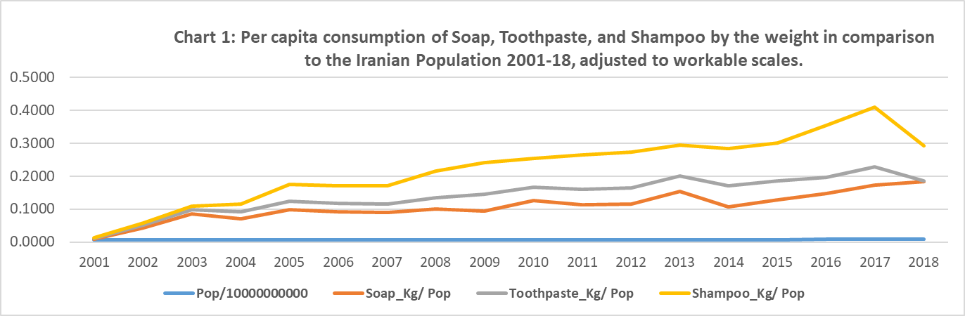

Line charts represent trends in per capita consumption of the three imported products in kilograms during periods 2001-18. They are not adjusted to the scaled values on the vertical legend on the left side of the chart (kilograms per person per year). Rather, they are stacked over each other in order to facilitate the observation of their movement through the period in comparison to the trend in population growth (blue line on the floor of the chart). This format of line chart vividly shows the trends of consuming of the three products moving upward in volume at a higher rate than population growth.

**Exhibit 1**: The statistical analysis of the significance of the equal rate of growth in per capita consumption of soap, toothpaste, and shampoo with the rate of population growth in Iran during the period 2003-2017. Note: Data for years 2001-2002 and 2018 were not included in the analysis as they pertain to periods of extreme conditions which adversely affected the environments for import.



The analysis, supported by the Statistical Package for the Social Sciences (SPSS), supplies sufficient evidence to reject the null hypothesis that the means of the per capita consumption of toothpaste and shampoo over the 16-year period is equal to or less than the mean of the growth in total population of Iran during the same period (p<0.05 for toothpaste and shampoo). We failed to reject the null hypothesis for soap, however. Accordingly, we reject the null hypothesis and accept the alternative hypothesis that the Iranian consumption of the toothpaste and shampoo has been significantly higher than the growth rate in population. Indeed, the Iranians increased their consumption of high quality imported personal hygiene products, demonstrating a high level of commitment to personal hygiene, year after year.

Elsewhere in the region, global manufacturers of personal hygiene products adjust their product mix to the evolving consumer orientation toward nature-based products. Hindustan Unilever has been importing a nature-driven product group for its soap, shampoo, and conditioners in order to penetrate into this newly attractive market (Malviya, 2019).

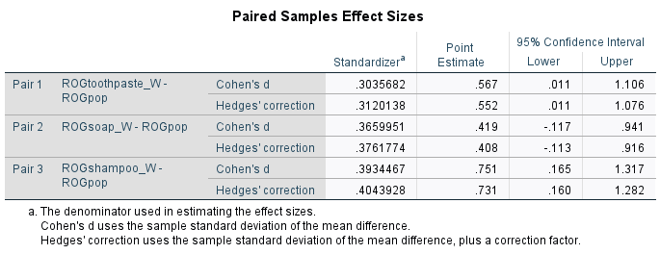

The Cohen’s d test of effect sizes produced a standard deviation of 0.3660 for soap, 0.3036 for toothpaste, and 0.3934 for shampoo. As these values fall between the low effect of 0.2 and the medium effect of 0.5 standard deviations, we can conclude that the rate of growth in consumption of each of these three products over the span of 16 years in not much apart from the rate of population growth during the same period. Cohen’s d test thereby suggests that the magnitude of change between each of the two variables is close to one another, suggesting …..

[Raja 2: would you kindly advise me on how is it best to finish this sentence? How can the close difference between the paired means, measured by their standard deviations, would provide additional information to the reader?]

**Caveat 1**: With reference to the notion that the rate of increase in per capita consumption of personal hygiene care products is significantly higher than the rate of increase in population growth, a caveat may be noted in the interpretation of the commitment of the Iranian consumers to quality imported products. A higher volume of purchase may reflect submission to higher prices with no tendency to purchase more of the personal hygiene products. To mediate this possible error in perception, we must bring into analysis the factor of price increases.

**Paradigm 2**: Iranian consumers would have demonstrated a genuine commitment to the purchase of high priced/high quality international brands of personal hygiene products if the amount they spent on their import/consumption was higher than the rate of increase in prices. Accordingly,

Ho: ROGcifrs,t,sh-2003-2017 ≤ ROGprs,t,sh-2003-2017

Ha: ROGcifrs,t,sh-2003-2017 > ROGprs,t,sh-2003-2017

where,

ROGcifr = Rate of Growth for the value of the import of (in Rial):

S = Soap in Iranian Rial (annual volume during 2003-2017)

T = Toothpaste in Iranian Rial (annual volume during 2003-2017)

Sh = Shampoo in Iranian Rial (annual volume during 2003-2017)

ROGpr= Rate of Growth in the price of imported (in Rial):

S = Price of Soap in Iranian Rial per kilogram during 2003-2017

S = Price of Toothpaste in Iranian Rial per kilogram during 2003-2017

Sh = Price of Shampoo in Iranian Rial per kilogram during 2003-2017

**Table 2:** The CIF values of the total import of soap, toothpaste, and shampoo in Iranian local currency (Rial) in comparison with their prices in local currency by kg during 2003-2018.



Source: Iran Customs Organization.

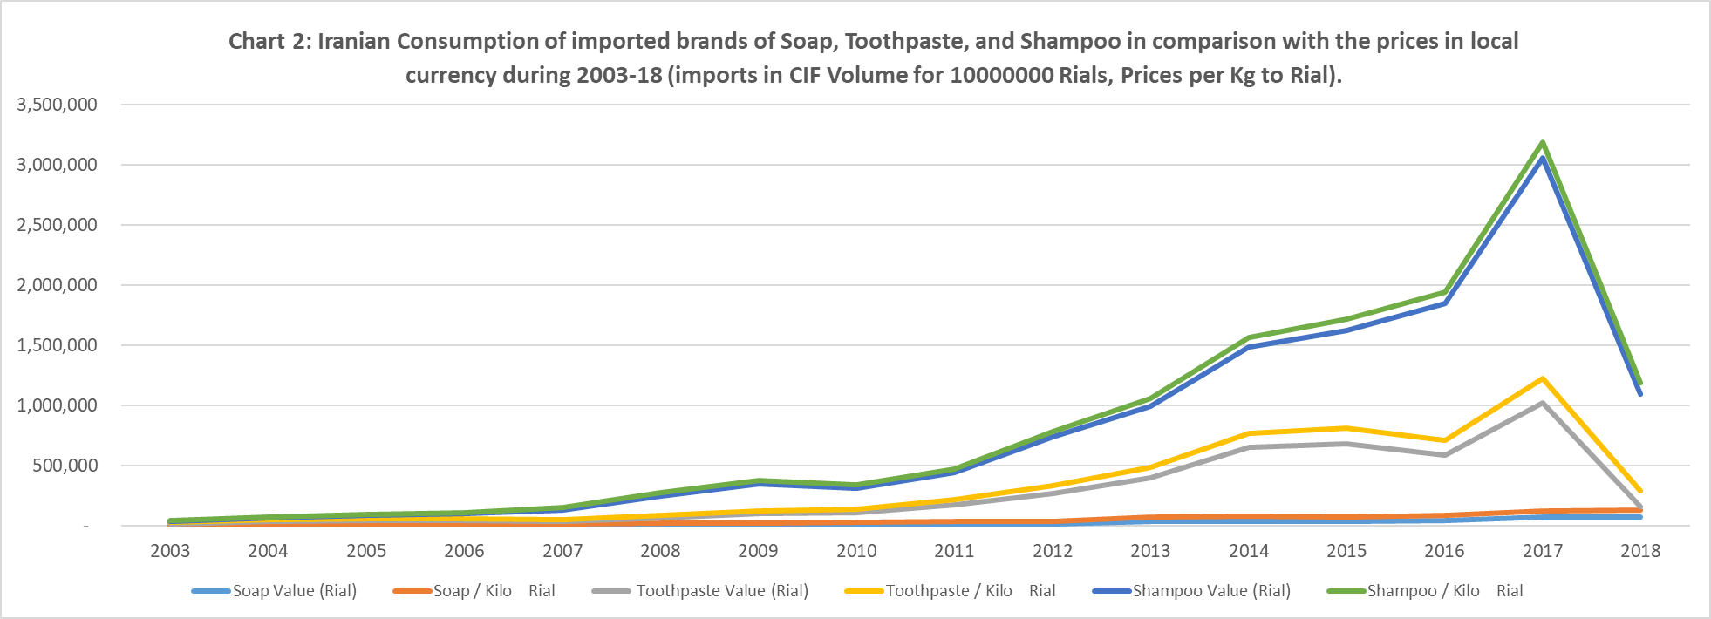

Trend lines in chart 2 exhibit the movement of consumption of imported brands of soap, toothpaste, and shampoo closely followed by the trending price changes for these products during period 2003-2018. However, as it is noted below, there is a significant difference between the rate of rising prices and the volume of expenditure that the Iranian consumers spend to acquire them. The magnitude of difference reveals that Iranian consumers incurred financial sacrifices to purchase more of the quality imported personal hygiene products year after year even when prices rose dramatically.

**Exhibit 2:** A statistical analysis regarding the significance of the equality in the rate of growth of the import of soap, toothpaste, and shampoo, measured by the CIF value of local currency, with their associated prices in kg during the 2003-2017 period. Note: Data for the year 2018 is not included as it pertains to extreme conditions which adversely affected the import environment during that year.

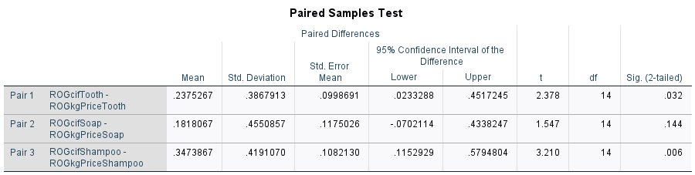

The result of the Paired Samples Test suggests that there is a significant difference between the means of the imported volume of toothpaste and shampoo in Iran (CIF in Rial) and their prices per kilogram in rial (p=0.032 and p=0.009, respectively) during the period of interest (2003-2017). The outcome does not support the hypothesis that a significant difference exists between the rate of increase in import volume, and the price of soap (p=0.144) during the same period.

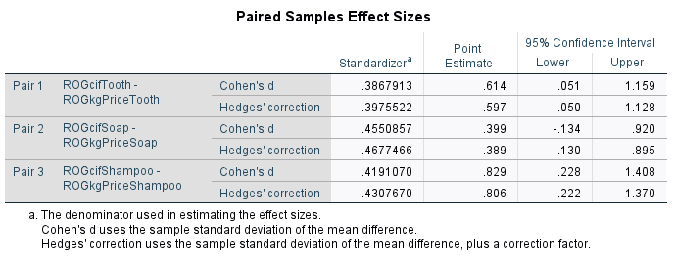

Cohen’s d test of effect sizes delivers the standard deviations of 0.614 for toothpaste and 0.829 for shampoo, further suggesting a high magnitude of difference between the rate of growth in population and the rate of growth in consumption of the two items. The result confirms that the volume of expenditure that Iranians spent on purchasing high-quality imported products were substantially higher than the level of price increases over the 15-year period.

**­­­­­­­­­­­­­­­­­­­­­­­­­­­­­­­­Caveat 2**: The notion of commitment to the purchase of high priced/high quality imported products, measured by the increase in the level of imports in local currency, being at a higher rate than the rate of population growth, may not be a genuine indicator of the national commitment if the additional annual expenditure is not adjusted for inflation.

**Paradigm 3:** The national commitment to the purchase/consumption of high quality/high priced imported personal hygiene items would be at least partially demonstrated when the rate of inflation adjusted value of imports is significantly higher than the rate of growth in total population. Accordingly,

Ho: ROGviris,t,sh-2003-2017 ≤ ROGpop-2003-2017

Ha: ROGviris,t,sh-2003-2017 > ROGpop-2003-2017

where,

ROGviri = The rate of growth in the value of imported products in Iranian Rial adjusted for the rate of inflation, for:

S = The inflation-adjusted CIF value of the volume of imported Soap in local currency, Rial

T = The inflation-adjusted CIF value of the volume of imported Toothpaste in local currency, Rial

Sh = The inflation-adjusted CIF value of the volume of imported Toothpaste in local currency, Rial

ROGpop-2003-2017  = Annual rate of growth in population of Iran during 2003-2017 period.

**Table 3**: The volume of the imports of soap, toothpaste, and shampoo in local currency (CIF-Rial), adjusted for the inflation rate, in comparison to the increase in the rate of total population in Iran during 2003-2018. Data for the imports are scaled down to facilitate visual comparison.



Sources: Central bank of Iran, Iran Customs Organization, Statistical Center for Iran.

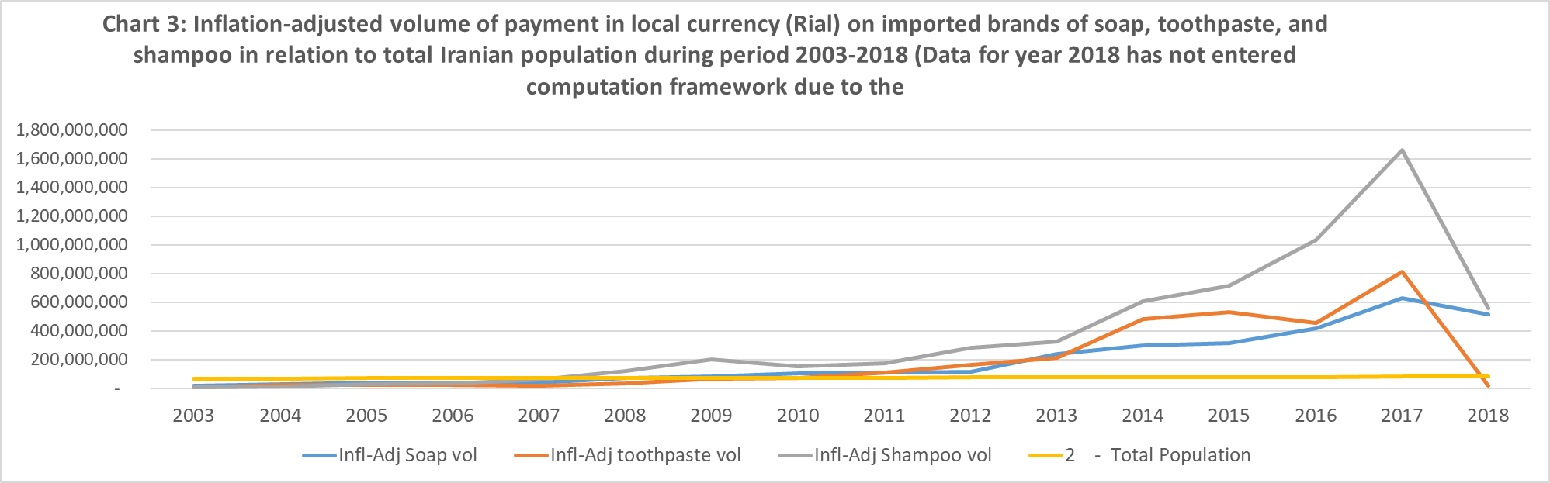

Line charts exhibit the rate of growth in inflation adjusted volume of expenditure on the three imported personal hygiene items have moved gradually, and at a higher rate than the rate of growth in total population (orange line). This means that in real terms, the Iranians spent more of their personal wealth on quality personal hygiene products year after year to increase their immunity against environmental pollutive particles.

**Exhibit 3:**

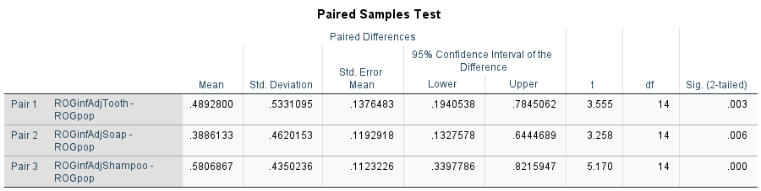

The outcome of the Paired samples test reveals a significant difference between the means of the imported volume of all three products of interest in their inflation-adjusted values of Iranian Rial, and the change in total population during the period of interest, 2003-2017 (Toothpaste p=0.003; Soap p=0.006; Shampoo p=0). This result is achieved with 95% level of confidence. The outcome suggests that the commitment of the Iranians to consume higher quality imported hygiene products exceeded the rate of growth while adjusting to the rate of annual inflation. As the population grew by 18.42% during the 14-year period, the rate of growth in inflation-adjusted import of the soap, toothpaste, and shampoo raised by 3046%, 9,317%, and 29,024% respectively.

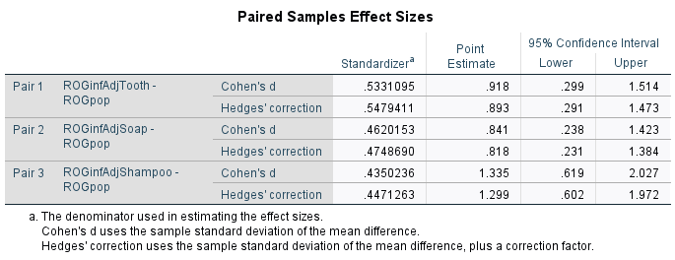

Cohen’s d test of effect size delivers the standard deviations of 0.918 for the Toothpaste, 0.841 for Soap, and 1.335 for Shampoo. As a standardized deviation of 0.8 is commonly believed to be a benchmark for a high level of difference between the rate of growth of these three products with the rate of population growth over the 16 years of observation, we can conclude that magnitude of difference between the consumption and population growth has been high.

**Caveat 3**: The concept of consumer willingness to purchase imported brands, measured by the higher rate of annual expenditure, than the rate of population growth could be challenged by the impact of their personal income on the purchase of higher priced imported items. If per capita income increases at a rate equivalent to or higher than the volume of money spent on the purchase of imported items, the higher volume of inflation adjusted money spent on imported goods could be attributed to the enjoyment of higher purchasing power, rather than a genuine interest in using higher priced/higher quality personal hygiene products. Only when the rate of growth in the money spent on imported hygiene products exceeds the rate of growth in gross national income (GNI), the phenomenon would suggest a genuine intention to consume higher quality personal hygiene products. Accordingly,

**Paradigm 4**: Iranian consumers’ adherence to quality personal hygiene products can be determined, among other factors, by their willingness to purchase imported items at a higher rate than the rate of growth in their personal income. We have used data for per capita GNI, measured in purchasing power parity (PPP), supplied by the Central Bank of Iran (CBI) to measure the difference between the rates of growth in the consumption of imported personal hygiene products and the rate of growth in household income. Therefore, the following hypothesis can be set:

Ho: ROGviris,t,sh-2003-2017 ≤ ROG-2003-2017

Ha: ROGviris,t,sh-2003-2017 > ROGpcir-2003-2017

where,

ROGviri = The rate of growth in the value of imported products in Iranian Rial adjusted for the rate of inflation, for:

S = The inflation-adjusted CIF value of the volume of imported Soap in local currency, Rial

T = The inflation-adjusted CIF value of the volume of imported Toothpaste in local currency, Rial

Sh = The inflation-adjusted CIF value of the volume of imported Shampoo in local currency, Rial

ROGpcir = Per capita GNI in PPP values in Iranian Rial during the period 2003-2017.

**Table 4:**



Sources: Iran Customs Organization, Iran Statistics Center, Central Bank of Iran.

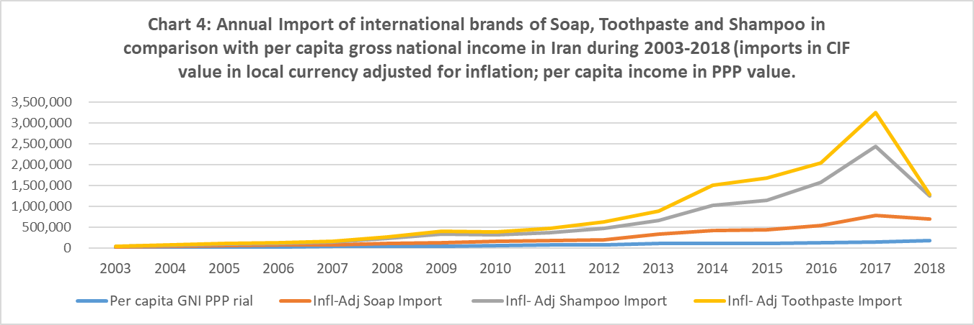

Line charts depict a growing rate of consumption of imported soap, toothpaste, and shampoo during the 16 years of studies in comparison to their purchasing power parity in Iranian Rials. The results suggest that the intention of the Iranians to utilize high quality personal hygiene products exceeded the level of their empowerment to buy them as a result of a rise in economic prosperity.

**Exhibit 4:**

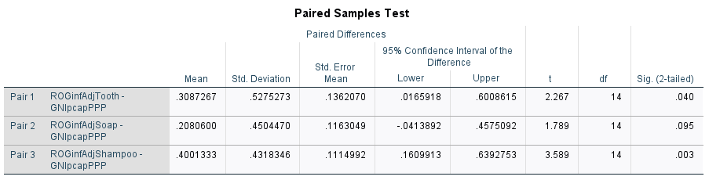

The result of the Paired samples test suggests that there is a significant difference between the means of the imported volume of toothpaste and shampoo measured by their inflation-adjusted values of Iranian Rial, and the Iranian purchasing ability for imported brands of toothpaste, and shampoo. It was assessed by their purchasing power parity during the period of interest, 2003-2017, while tolerating a 5% level of error in judgment. The p values are 0.040 for toothpaste, and 0.003 for shampoo. The p=0.095 does not reject the null hypothesis, however. Nonetheless, the outcome confirms that the Iranian commitment to consumption of high quality imported personal hygiene products was not necessarily the result of their higher income, rather, their strong stand for their hygiene care, as the rate of their expenditure on this product group significantly exceeded the rate of increase in their personal income.

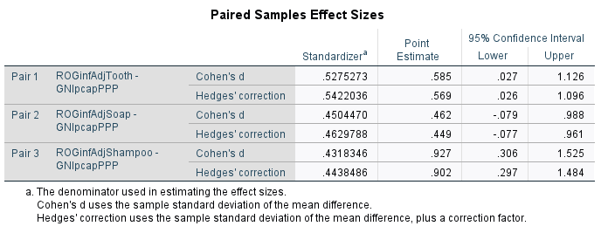

Cohen’s d test of effect size delivers the standard deviations of 0.585 for the toothpaste, 0.462 for soap, and 0.927 for shampoo. As a standardized deviation of 0.8 commonly sets a benchmark for a high difference between the means of two variables, the Cohen’s d test confirms the hypothesis that the extent of the Iranian consumers’ adherence to their sanitary issues far exceeds the level of additional income through the period of 2003-17.

**Additional Statistical Consideration**

We were initially concerned about the possible presence of autocorrelation between the rate of growth in various factors which we had considered in our analysis; namely the rate of population growth, the rate of growth in imports of soap, toothpaste, and shampoo, the rate of inflation, and the rate of growth in purchasing power parity. We have conducted the first order autocorrelation analysis using SAS statistics to measure the extent of differences for each of the paired sample t-tests. The following table exhibits the outcome.

Table 5: Values Presenting the Outcome of the Autocorrelation Test for Paired Sample t-tests Using SAS. Critical values for a 95% confidence interval fall between -1.96 and +1.96 standard deviation.



As noted, the outcome for each test suggests the absence of autocorrelations in all the paired sample t-tests. They confirm our assumptions that the observations are independent. For mathematical foundation see Moron (1948).

**Contributions from the Local Developers**

The perceived superior quality of the international brands does not necessarily imply the poor quality of the domestic brands. Indeed, a number of R&D institutes are set up throughout Iran to conduct advance laboratory research on development of high-quality personal hygiene products. Samples of their achievements are mentioned below.

1. In the Area of Toothpaste

Rajabi (2013), a dentist at Mashhad Medical University (northeast Iran), developed a toothpaste which has polymers acting like saliva proteins that remain on the gums and prevents dry mouth. The content involves a natural-based thin layer which sits on mucus and gums, preventing dry mouth which is the cause of mouth cancer in many patients. Dr. Rajabi noted that the foreign version of this toothpaste contains artificial additives while his new formula contains 90% of natural substances. Furthermore, in a clinical study aimed at reduction of dental caries among children, Khalili Sadrabad et. al. (2019) at the Faculty of Dentistry at Tabriz University of Medical Sciences (northwest Iran) concluded that the incorporation of fluoride into fissure sealants can be effective in inhibiting dental caries. It is aimed at decreasing the prevalence of dental caries.

Kooshki (2018) at the University of Medical Sciences in Tehran, Iran, studied the antimicrobial effect of Iranian-made herbal toothpaste compared to chemical composed toothpaste. The results showed that when it is used with the same concentrations, the herbal toothpaste was just as effective as the chemical toothpaste.

Sadeghi-Nejad (2018) and colleagues conducted a study in 2018 examining the effectiveness of toothpastes made from medicinal plants in Iran in preventing dental cavities. Their study concluded that the Iranian plant-based toothpaste was effective against all oral diseases they tested. More research is necessary for concrete results.

A study conducted in Foltash, Isfahn, Iran, by Ebadifar, Nomani, and Fatemi (2017) tested the effectiveness of nano-hydoxyapatite (NHA) on microhardness of caries. They concluded that the toothpaste with NHA was more effective at treating caries than the toothpaste without NHA. By the same token, Estaji and colleagues (2016) researched the effect of using a toothbrush and toothpaste versus a swab and chlordexidine solution on patients in intensive care units in Sabzevar, Iran. They found that using toothpaste and a toothbrush was more effective at preventing oral lesions. Yaghini, Motazavi, Haghshenas, and Mogharehabed (2014) assessed the fluoride levels of four popular toothpaste brands in Iran. They found that all had adequate fluoride levels to prevent dental caries.

1. In the Area of Shampoo

In a scientific study conducted at Mazandaran University of Medical Sciences in Sari, Iran, Azadbakht (2018) and colleagues tested the effectiveness of licorice-based shampoo. They found that licorice shampoo worked well to cleaning hair as well as treating certain hair and scalp diseases. Also in 2018, Chaijan et. al. conducted a study in Shiraz, Iran, by testing the effectiveness of Myrtus shampoo for treating dandruff. The results showed that Myrtus is an effective treatment for dandruff. It appears that the local personal hygiene industry in Iran has also been active in producing quality products which help prevent environmental diseases. Combining the power of global with the local brands of hygiene products, we note a genuine attempt of the Iranians to equip themselves against the spread of diseases. The spread of the pandemic should be attributed to other factors which need to be investigated.

**Summary and Conclusion:**

While the world is anxiously monitoring the spread of COVID-19 in virtually every place on planet Earth, the relatively high rate of infection and deaths among the nations of Russia and Iran has received considerable attention. There has been initial concern that a possible lack of commitment to personal care practices by the citizens of the Islamic Republic of Iran has been the main cause of spread of the pandemic. By analyzing serial data on the import/consumption of high-quality global brands of personal hygiene products, along with related data on the Iranian economy during the past 17 years, we have noted an increasing level of commitment to the use of quality products during the relatively long period. As an indicator of the consumer loyalty to perceived quality of personal hygiene product group, we selected three items--soap, toothpaste, and shampoo--which are widely used by practically all Iranians in their daily lives.

The findings reveal that the Iranians consumed a higher quantity of these three products over the span of 17 years. The rate of increase in their annual consumption has been significantly higher than the rate of population growth during the same time period. The level of increase in consumption is not necessarily based on the quantity used per household in their daily usage. Rather, it can also be attributed to the number of Iranians who have switched from domestic brands to global products because of the perceived superior quality of international brands. We have used a series of related economic data, such as per capita income and the rate of inflation, to augment the scope of our analysis and arrive at a more reliable conclusion. Our Findings are in harmony with the study of the marketing experts which forecast the level of demand for soap, Edible Oil Co-Products and Bi-products, in the entire region of the Middle East will substantially rise to $257.2 Million by 2024 (PR Newswire, 2016)

This would indicate an increasing level of consumers’ commitment to personal health.

Our analysis further suggests that factors outside the personal commitment to healthcare have been responsible for the relatively rapid and sustained rate of spread of the pandemic. The analysis of these external factors is beyond the scope of this article. It is recommended that extended research be conducted to examine the true cause of rate of COVID-19 widespread in the Islamic Republic of Iran. We also recommend that a comparative study of this global phenomenon be made between Russia and Iran to determine commonalities in the cause of infection and to develop new protocols for their containment.

One of the factors which need to be explored refers to origin of perceived quality. So far, we have based our assumption of the consumer understanding of the superior quality of imported personal hygiene products on the presumed high quality of the active ingredients and efficient manufacturing process embedded in them. Research in the regional markets exhibited that this presumption may not be true. Indeed, the affective marketing and promotional positioning strategies of multinational firms could have engraved in the consumer’s mindset a higher value of the global brands than their local counterparts deserve. In a study of five multinational firms in Pakistan including Unilever’s Lux brand of soap, which commands the market-leader position in the country, Billah (2018) concluded that emotional appeal to female consumers of ages 18-27 residing in urban areas has been used to create a highly desirable brand position for Lux. Whether the global brand utilizes high-quality ingredients is not discussed with the audience.

Another short coming of the present essay is that the scope of this analysis was confined to national brands, whether they were local or imported. A study by Dimitrieska et al (2017) in the regional market of Pakistan reveals that an increasing number of consumers are switching to private brands (those which were ordered by wholesalers and retailers and carry their own names). This phenomenon appeared because the economic conditions placed a cap on consumer’s purchasing power. Future studies should extend the domain of this research to private brands as well.